42. Trapping Rain Water

Given *n* non-negative integers representing an elevation map where the width of each bar is 1, compute how much water it is able to trap after raining.

For example,

Given [0,1,0,2,1,0,1,3,2,1,2,1], return 6.

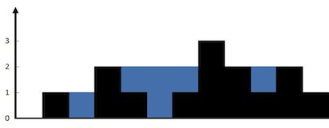

The above elevation map is represented by array [0,1,0,2,1,0,1,3,2,1,2,1]. In this case, 6 units of rain water (blue section) are being trapped.